Car Engine SFX

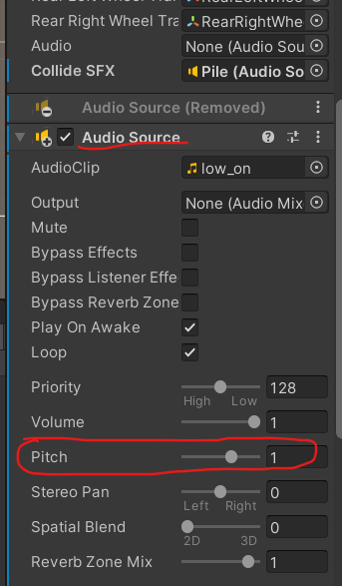

Pitch of the audio source is controlled and varied according to current speed of the car.

